

**Name:** Rutaba Hayat

**Reg no.** FA23-BSE-220

**Course:** Object Orientated Programming

**Submitted to:** Sir Shahid Bhatti

**Outputs**

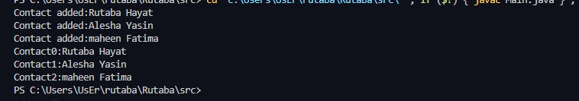

C:\Users\YA ALLAH\AppData\Local\Microsoft\Windows\INetCache\Content.Word\after deleted messages.png

